**PROGRAM 7**

**Aim:**Demonstrate the use of matplotlib library.

**Code:**

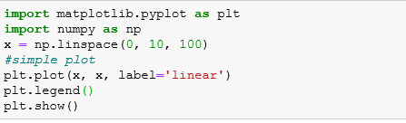

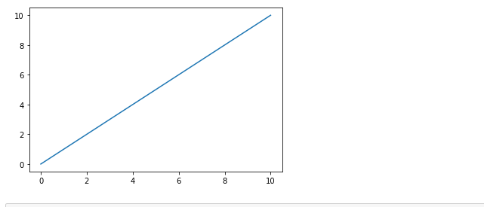

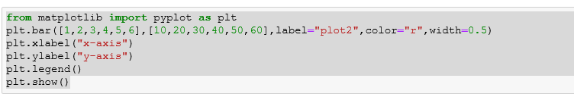

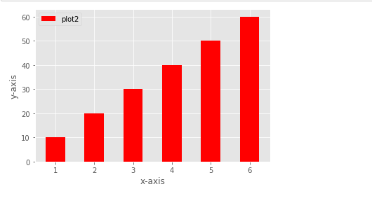

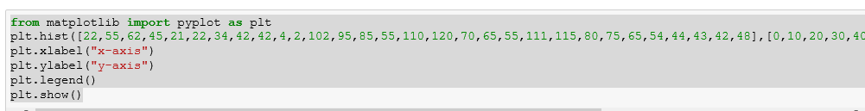

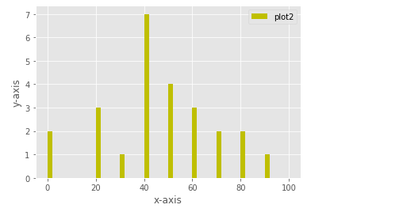

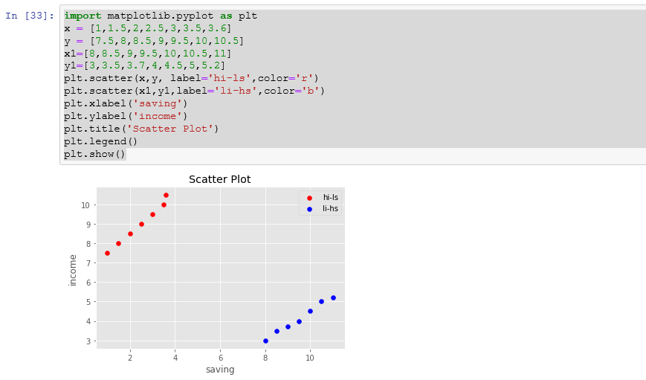

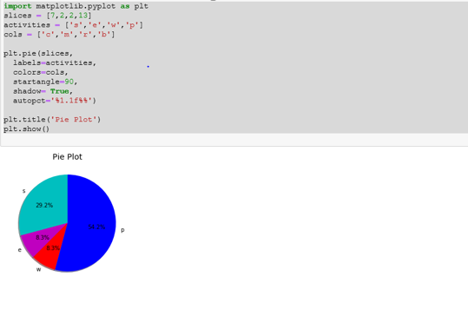

**Aim:**Plot the following equations:-

**Code:**

$y=\left\{\begin{aligned}1 x<10 \\ 0 else\end{aligned}\right.$

import matplotlib.pyplot as plt  
x=[num for num in range(0,20)]  
y=[]  
for i in x:  
 if i>=10:  
y.append(1)  
 else:  
y.append(0)  
plt.plot(x,y)  
plt.xlabel("x axis")  
plt.ylabel("y axis")  
plt.title("y=1 if x>=10 else y=0")  
plt.show()  
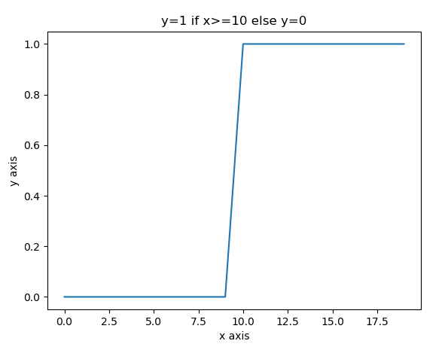

1. **. $y=e^{ax}$ for different values of a.**

import numpy as np  
import matplotlib.pyplot as plt  
num=[num for num in range(0,10)]  
a=2 #constant value  
x=np.array(num)*2  
y=np.exp(x)  
plt.plot(x,y)  
plt.xlabel("x axis")  
plt.ylabel("y axis")  
plt.title("y=e**ax")  
plt.show()

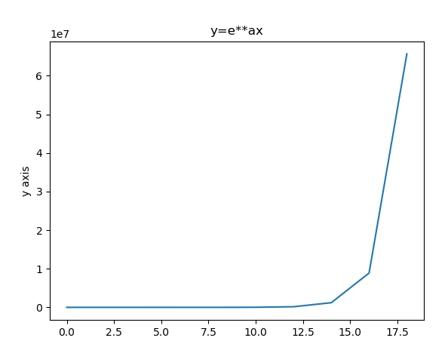

**3**. $y={7x}^{2}+3x+10 for 2≤x≤5$

import matplotlib.pyplot as plt  
x=[x for x in range(2,6)]  
y=[]  
for i in x:  
y.append(7*pow(i,2)+3*i+10)  
plt.plot(x,y)  
plt.xlabel('x axis')  
plt.ylabel('y axis')  
plt.title('y=7x^2+3x+10')  
plt.show()

$$4.y=\frac{1}{1+e^{-x}}$$

import matplotlib.pyplot as plt  
import numpy as np  
x=[x for x in range(0,20)]  
p=np.array(x)  
p=1+np.exp(-p)  
y=1/p  
plt.plot(x,y)  
plt.xlabel('x axis')  
plt.ylabel('y axis')  
plt.show()

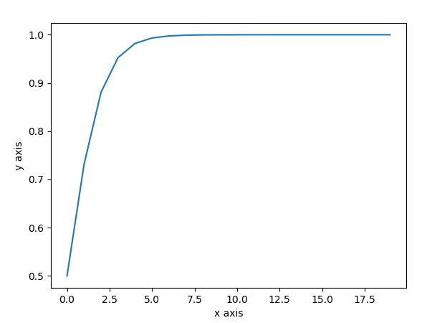

**5. $y=\frac{1-e^{-ax}}{1+e^{-ax}}$ for different values of a.**

import matplotlib.pyplot as plt  
import numpy as np  
num=[num for num in range(0,21)]  
num=np.array(num)  
a=2  
p=1-np.exp(-num*a)  
q=1+np.exp(-num*a)  
y=p/q  
plt.plot(num,y)  
plt.xlabel('x axis')  
plt.ylabel('y axis')  
plt.show()

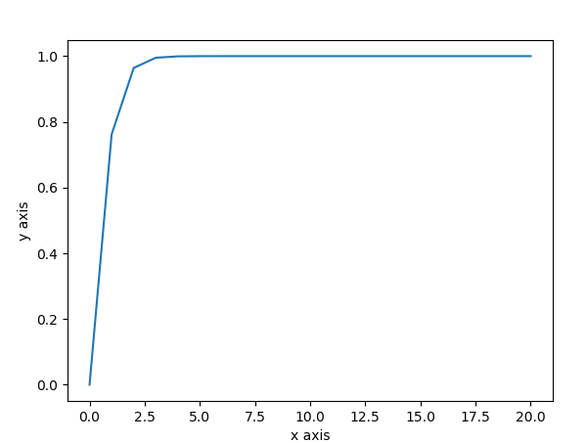

**6. $y=\tan{hx}$**

import numpy as np  
import matplotlib.pyplot as plt  
in_array = np.linspace(0, np.pi, 12)  
h=2  
out_array =h*np.tan(in_array)  
print("in_array : ", in_array)  
print("\nout_array : ", out_array)  
# red for numpy.tan()  
plt.plot(in_array, out_array, color='red', marker="o")  
plt.title("numpy.tan()")  
plt.xlabel("X")  
plt.ylabel("Y")  
plt.show()

